An Android-Based Mobile Application for Dormitory and Boarding House Finder for Students in High-Demand Areas

A Thesis Study
Presented to the Faculty of
College of Computer Studies at Rizal College of Taal

In partial fulfillment
of the requirements for the Degree
BACHELOR OF SCIENCE IN COMPUTER SCIENCE

Group 10
Añar, Aira Christyl O.
Martin, Jade Cedrick P.
Encarnacion, Jhon Maelbert S.

Gerald C. Manalo
Thesis Adviser

2025

CHAPTER I
INTRODUCTION
Project Context
Finding suitable housing has always been a significant challenge for students relocating to urban and high-demand areas for their studies. Many struggle to secure accommodations that meet their needs for affordability, safety, and accessibility. Traditional methods, such as word-of-mouth recommendations or browsing unverified online listings, often result in misinformation, wasted time, and increased stress. With the rapid advancement of technology, mobile applications have transformed various industries—yet the student housing market remains largely inefficient. Can an Android-based solution bridge the gap between students searching for accommodations and landlords seeking tenants?
The demand for student accommodations has grown due to the increasing number of students relocating for higher education. In areas within Batangas and Lipa, which are considered major academic hubs, students frequently encounter difficulties in securing dormitories due to limited access to verified and real-time housing information. Currently, students depend on informal channels, which may not always provide complete or reliable details. Landlords, in turn, face challenges in reaching prospective tenants, leading to low occupancy and inefficient property management.
Mobile technology offers a powerful tool to address these issues. An Android-based mobile application, equipped with features such as advanced search filters, real-time availability updates, an interactive map powered by Google Maps, and a direct messaging system, can significantly improve the housing search experience. The inclusion of an online payment system allows students to securely pay for reservations directly through the app. Furthermore, the system will support offline access to previously synced dorm listings, enabling students to search for accommodations even without an active internet connection.
Several studies have demonstrated the effectiveness of mobile applications in improving student housing accessibility. For example, Baldicanas et al. (2022) developed an Android-based Boarding House Management Information System that streamlined property listing, tenant monitoring, and booking confirmations—showcasing how mobile platforms can enhance both landlord operations and tenant experience. Meanwhile, The Application of Boarding House Rental Location Search System Based on Android (2021) emphasized the impact of integrating geolocation and search filters in streamlining the booking process.
This project is important as it tackles a common problem faced by both students and landlords using a technology-based solution. The mobile application will serve as a reliable platform for students to find dormitories based on location, budget, and amenities. Landlords will benefit by being able to advertise their properties more efficiently and communicate with potential tenants directly. Universities and colleges can also recommend the app to help students find safe and suitable accommodations. Overall, the app will enhance accessibility, communication, and organization in student housing within Batangas and Lipa.

Purpose and Description
This study aims to develop a mobile application that streamlines the process of finding dormitories and boarding houses for students in high-demand areas like Batangas. Many students face difficulties in securing safe, affordable, and accessible accommodations due to the lack of a centralized platform that provides accurate and real-time housing information. This project seeks to address this gap by offering an efficient, user-friendly mobile application tailored to the needs of students and landlords.
The proposed application will integrate key features such as search and filtering options, real-time availability updates, and direct communication between students and landlords. To enhance accessibility, the system will also support offline viewing of previously synced available listings, allowing users to search for accommodations even without an internet connection. An interactive map will be incorporated to visually display nearby accommodations and landmarks, utilizing either the Google Maps API or the open-source OpenStreetMap as a flexible alternative. While Google Maps offers robust and widely used mapping services, OpenStreetMap provides a cost-free, open-access solution, ensuring full functionality even without commercial licensing—particularly useful for academic deployment and long-term sustainability. Additionally, an online payment system will be implemented, allowing students to securely reserve and pay for accommodations directly through the application.
This proposed mobile application, An Android-Based Mobile Application for Dormitory and Boarding House Finder for Students in High-Demand Areas, will benefit the following:
- To the Students- They will have access to a secure, accessible, and reliable platform that simplifies the search and reservation process. The ability to filter results, view maps, check real-time availability, and pay online helps them make informed decisions more efficiently—even offline.
- To the Landlords and Dormitory Owners - They can manage property listings, update availability in real time, communicate directly with potential tenants, and receive payments through the app, helping them reduce vacancies and increase efficiency.
- To the Future Researchers – This study may serve as a foundation for future development in mobile applications, geolocation integration, offline-first system architecture, and student accommodation platforms. It provides a model for extending functionality, improving user experience, or expanding to other geographic locations.

Statement of the Problem
This study aims to address the difficulties students face in finding suitable dormitories and boarding houses in high-demand within Batangas and Lipa. The lack of a centralized platform leads to inefficiencies in the search process, unreliable information, and limited communication between students and landlords. To address these challenges, this study seeks to answer the following research questions:
- How can an Android-based mobile application be developed to help students search and reserve dormitories and boarding houses within Batangas and Lipa?
- What filtering system should be implemented to allow users to sort listings?
- What methods can be used to evaluate the system’s usability and performance?

Objective of the Study
- To develop an Android-based mobile application that allows students to search, filter, and reserve available dormitories and boarding houses within Batangas and Lipa.
- To integrate a filtering system that used a multi-criteria search and filter mechanism powered by Firebase Firestore queries for real-time online access, and a local cache-based filter (e.g., using SQLite or SharedPreferences) for offline use.
- To ensure system usability and performance by conducting user testing and feedback analysis.

Scope of the Study
This study focuses on the development of an Android-based mobile application that serves as a centralized platform for students to find dormitories and boarding houses in high-demand academic areas, specifically within Batangas and Lipa.
The application will provide essential features such:
- For Students:
  - Search and Filtering System – Allows students to find accommodations based on location, price range, amenities, and other preferences.
  - Offline Search for Available Dorms – Allows students to view a cached list of available dormitories even without an internet connection. The data is updated whenever the user reconnects to the internet. Mayabang kaa boiiii
  - Interactive Map – Displays property locations and nearby landmarks using mapping APIs.
  - Real-Time Availability Updates – Shows updated occupancy status of properties.
  - Reservation System – Students can reserve available accommodations directly through the mobile app.
  - Direct Messaging System – Facilitates communication between students and landlords for inquiries and negotiations.
  - User-Generated Reviews and Ratings – Enables students to leave feedback, helping others make informed housing decisions.
  - Online Payment - Enables students to securely pay for bookings through digital channels integrated in the app (e.g., GCash, PayMaya).
Note: For thesis demonstration purposes, payment transactions are simulated; production deployment would require business registration and formal payment gateway API integration with authorized payment service providers.
- For Landlords:
  - Real-Time Availability Updates – Allows landlords to indicate current occupancy status.
  - Property Management Features – Lets landlords list properties, update details, and manage reservations.
  - Direct Messaging System – Enables landlords to respond to student inquiries and negotiations.
Geographic Focus Implementation:
The application maintains its focus on Batangas and Lipa through operational controls during landlord registration and listing approval processes. This approach provides flexibility for system scalability while ensuring that initial deployment concentrates on the target high-demand areas. Location data is validated during property listing submission to ensure relevance to the target geographic region.

The primary users of the system will be:
- Students looking for dormitory or boarding house accommodations.
- Landlords and dormitory owners who want to list and manage rental properties.
The study will cover the design, development, and initial testing of the mobile application to ensure usability, functionality, and efficiency. It will evaluate the system based on performance, user experience, and effectiveness in improving the housing search process.

Limitations of the Study
While this study aims to improve the efficiency of student housing searches, certain limitations must be considered:
- Geographical Scope – The application will primarily focus on dormitories and boarding houses within Batangas and Lipa only, particularly those located near schools and universities in Batangas and Lipa. Expansion to other areas will not be covered in this study.
- Offline Limitations – While offline search is available, it is restricted to the most recently synced data. Features like real-time chat, map updates, and reservations require an internet connection.
- Internet Dependency – As the platform relies on real-time data and cloud-based services, including map functionality (via Google Maps API or OpenStreetMap), users will require an active internet connection to access features such as booking, payment, and messaging.
- Device Compatibility – The app is optimized for Android devices only.
- Limited User Testing – The system will be tested with a selected group of students and landlords. Broader testing across different locations and institutions will be beyond the study's scope.
- Accuracy of User-Generated Content – While the app will include reviews and ratings, the accuracy and authenticity of user-generated feedback cannot be fully guaranteed.

Definition of Terms
The following terms used in this study are arranged alphabetically and defined based on their operational and conceptual use in the system:
Accommodation – Refers to dormitories, boarding houses, or other rental spaces listed in the mobile application for students seeking housing.
Boarding House – A rental property that provides lodging for students, often with shared facilities such as bathrooms and kitchens.
Dormitory – A student housing facility, usually located near educational institutions, that provides shared or private rooms for rent.
Filtering System – A feature in the mobile application that allows users to refine their search results based on specific criteria such as location, price range, amenities, and vacancy status.
Geolocation – A technology integrated into the application that enables real-time tracking and display of dormitory and boarding house locations on an interactive map.
Landlord – A property owner or manager who lists, maintains, and updates dormitory or boarding house information, including vacancy status, in the system.
Mobile Application – A software application developed for Android devices that enables students to search for, reserve, and communicate about rental accommodations.
Property Listing – An entry in the application that contains detailed information about a dormitory or boarding house, including rental price, location, available amenities, and vacancy status.
Real-Time Availability – Real-Time Availability – A feature that allows landlords to change and reflect the present vacancy status of their properties within the application, assisting students in identifying options that are currently accepting tenants.
Reservation System – A functionality within the application that enables students to secure a spot in a dormitory or boarding house by making a reservation request.
Review and Rating System – A feedback mechanism that allows students to evaluate and share their experiences regarding a specific dormitory or boarding house, helping others make informed decisions.
Rental Search System – The core system in the mobile application that enables students to search for dormitories and boarding houses using various filters and an interactive map.
Student Housing – type of residential accommodation specifically intended for students, including dormitories and boarding houses.
Tenant – A student who has rented or reserved a dormitory or boarding house through the application.
User Interface (UI) – The visual and interactive design of the mobile application that enables users to navigate and utilize its features efficiently.
Usability Testing – The process of evaluating the application's functionality, user experience, and efficiency through structured testing with students and landlords.

CHAPTER II
REVIEW OF RELATED LITERATURE
This chapter provides a review of related literature and studies relevant to the current research. These materials have given the researchers valuable insights and ideas, contributing to the formulation and development of the research problem. Additionally, this section includes a synthesis of the reviewed studies
Technical Background
The Dormitory and Boarding House Finder is an Android-based mobile application developed to streamline the student accommodation search process in high-demand areas such as Batangas and Lipa. The system is designed exclusively for Android devices.
A core feature of the system is its interactive map, which assists students in locating available accommodations and nearby landmarks. The application is designed to utilize the Google Maps API for real-time geolocation, map display, and navigation. However, in the event that project resources are limited or budget constraints arise, the researchers acknowledge OpenStreetMap as a viable alternative mapping service.
For enhanced functionality, the system includes multi-criteria filtering system, which enables users to search for accommodations based on location, price range, amenities, and real-time availability. The filtering method combines Firebase Firestore queries for dynamic online filtering and local storage-based filters (using SQLite or SharedPreferences) for offline search capability. This hybrid approach ensures accessibility even when users are temporarily offline, offering a cached list of available accommodations.
To enhance user interaction, the system includes a real-time availability update mechanism where landlords can update the status of their listings immediately, allowing students to view accurate and up-to-date information. A direct messaging system facilitates communication between students and landlords, improving negotiation and inquiry handling. Additionally, a review and rating feature supports feedback sharing for better decision-making by future tenants.
The application is optimized for a range of Android devices, ensuring lightweight performance and accessibility. It is developed using Java or Kotlin within Android Studio, adhering to Android’s Material Design guidelines for a consistent and intuitive user experience.
For data handling, the system uses Firebase Firestore as its main cloud database for storing user profiles, property listings, messages, and ratings. Firebase Cloud Storage is used to manage and retrieve images quickly and reliably. Google Authentication and email login options are implemented for secure access, ensuring both data security and user convenience. The online payment system, integrated with platforms such as GCash and PayMaya, enables students to pay securely within the application.

Related Literatures
Local Studies
Baldicanas et al. (2022) developed an Android-based Boarding House Management Information System aimed at improving the efficiency of managing boarding house operations for both tenants and landlords. The system focused on automating manual processes such as property listing, tenant monitoring, and booking confirmations, ultimately enhancing service delivery and tenant experience. This study is relevant to the current research as it demonstrates the practical benefits of using mobile technology to streamline rental management. Its findings support the proposed mobile application for dormitory and boarding house searches by showing how digital platforms can improve communication, efficiency, and user satisfaction—core goals shared by the present study, which further expands functionality with student-focused features like offline search, real-time availability updates, and online payment integration.
Curaza (2021) developed a mobile-based application aimed at addressing the common challenge tenants face when trying to locate suitable boarding houses. This study highlights the difficulties, especially for students, in finding affordable and accessible accommodations in unfamiliar cities. The research emphasized how mobile technology, integrated with GPS tracking and real-time housing information, can significantly enhance the process of searching for housing. By simplifying the process, it allows users to quickly find nearby boarding houses, streamlining what would otherwise be a time-consuming task. Curaza’s study serves as a foundational reference for the proposed Boarding House Finder mobile application, which seeks to improve students' housing accessibility by leveraging digital tools and smartphone usage.
Monteverde et al. (2023) explored the role of technology in enhancing the rental property market, emphasizing how most existing platforms focus on hotels and apartments while neglecting more affordable housing options such as boarding houses and bed spaces. This issue is particularly evident in Bansud and Bongabong, Oriental Mindoro, where individuals struggle to find suitable rentals due to the lack of accessible and detailed property listings. To address this gap, the authors developed a Web-Based Rental House Smart Finder using the Rapid Application Development (RAD) approach, which enables users to locate affordable rental properties, access essential details, find nearby listings based on location, and submit reservation requests. The system was evaluated using ISO/IEC 25010 software quality standards, achieving a high satisfaction rating of 3.67, with recommendations for a mobile application to improve accessibility. This study supports the need for a more inclusive rental search platform and reinforces the significance of mobile applications in streamlining the housing search process, particularly for students in high-demand areas.
Leona et al. (2023) developed and evaluated AppStay, a web-based reservation system for rooms, dorms, and apartments, utilizing the modified waterfall model to ensure efficiency and usability. The system was assessed by IT experts and accommodation providers in Sumacab Este, Cabanatuan City, receiving high ratings for its technical reliability and user experience. The study demonstrated the effectiveness of web-based applications in streamlining accommodation searches, highlighting the importance of usability and system performance. This research supports the current study by providing insights into the development and assessment of digital platforms for housing searches, reinforcing the need for user-centered design in creating an efficient mobile application for students seeking dormitories and boarding houses in high-demand areas.
The study by Sairen Abando, Louie Rose Granada, and Jhonel Bigata (2022) on the "On-Land: Boarding House Finder and Rental System" introduces a digital platform that simplifies the search for boarding houses in Irosin Municipality by allowing landlords to register and promote their properties while enabling tenants to browse listings with essential details like location. With a landlord module featuring registration, verification, and secure account management, the system ensures legitimacy and fosters trust between property owners and tenants. This study supports the research on "A Mobile Application for Dormitory and Boarding House Finder for Students in High-Demand Areas" by showcasing how technology can enhance efficiency and accessibility in housing searches. Like the proposed mobile application, the "On-Land" system leverages digital tools to streamline the rental process, demonstrating the value of real-time updates, secure user management, and online property promotion in addressing student accommodation challenges.

Foreign Studies
Effendy, Kartono, and Herawatie (2023) developed a mobile application using the Fuzzy TOPSIS method to help students find suitable boarding houses efficiently. Their study follows the waterfall software development model, focusing on construction and deployment. Through surveys based on ISO 9126, the app was rated 3.54, marking it as an excellent system in terms of functionality, usability, reliability, and performance. The research highlights the importance of digital solutions in simplifying student accommodation searches, aligning with the current study’s goal of developing an effective boarding house finder. Their findings support this study by emphasizing how mobile applications can improve accessibility and convenience, with user feedback suggesting enhancements like community features and ratings to boost engagement and usability.
Hamzah, Mustika, Mustapa, and Rahmah (2023) developed an Android-based boarding house location search system to assist students in finding nearby accommodations efficiently. Their study highlights the importance of boarding houses for students studying away from home, particularly those seeking convenience and reduced travel time to campus. By integrating features such as route searches and detailed boarding house information, the system streamlines the process for tenants while also allowing boarding house owners to manage and update their listings easily. Implemented using Android Studio and tested with the BlackBox method, the system was found to function effectively as intended. This study supports the research by demonstrating how mobile applications can significantly improve the housing search experience for students, aligning with the goal of creating a user-friendly dormitory and boarding house finder tailored to high-demand areas.
Odunuga Atinuoluwadide Moromoke and Olayinka Odutola (2023) introduce Student Nest, a mobile application designed to tackle a critical challenge for international students—securing a guarantor for housing. Many international students struggle to find accommodation due to guarantor requirements, which Student Nest directly addresses by providing a secure, user-friendly platform connecting students with qualified guarantors. With features like identity verification, seamless communication, and clear guidelines, the app simplifies the guarantor request process, making housing more accessible. This study supports the development of a dormitory and boarding house finder by demonstrating how technology-driven solutions can bridge gaps in student housing. By prioritizing user experience, security, and efficiency, Student Nest serves as a model for innovative applications that enhance accessibility, aligning with the study’s goal of improving housing options for students in high-demand areas.
Cocola-Gant, A., & Malet Calvo, D. (2023) conducted an in-depth analysis of Uniplaces, a digital platform facilitating mid-term student rentals in Lisbon. Their study highlights how Uniplaces transformed the student housing landscape by centralizing listings, offering secure online transactions, and providing a user-friendly interface for international students. The platform's model, akin to Airbnb, allowed students to book accommodations remotely, reducing reliance on informal channels like classified ads and social media groups. This digital shift not only streamlined the rental process but also increased accessibility and trust among users. The study underscores the significant role of digital platforms in modernizing student housing markets and enhancing the rental experience for mobile student populations.
Mustofa Abi Hamid and Reza Pratama (2025) developed a web-based boarding house information system integrated with GPS to address the inefficiencies of traditional student accommodation searches. Their study highlights the limitations of word-of-mouth recommendations, which often lead to outdated or misleading information, making it difficult for students to find suitable housing. By employing the waterfall model—covering analysis, design, coding, and testing—the researchers created a user-friendly platform that provides accurate, real-time data on available boarding houses, including pricing and location details. Their findings demonstrated high feasibility and user satisfaction, proving the system’s effectiveness in streamlining the accommodation search process. This study directly supports the development of a mobile application for dormitory and boarding house searches in high-demand areas by showcasing the importance of accessibility, real-time information, and user-centered design in improving student housing experiences.

Synthesis of the Study
Both local and foreign studies emphasize the pivotal role of digital platforms in transforming the student housing search experience, particularly in areas with high demand for accommodation. Local studies, such as those by Curaza (2021), Baldicanas et al. (2022), and Monteverde et al. (2023), have demonstrated how mobile applications with GPS integration, real-time updates, and multi-criteria filtering improve the efficiency of locating boarding houses. These systems serve as the foundation for the current study, which adopts and enhances these features by adding offline access, direct messaging between students and landlords, user-generated reviews, and secure online payments.
Foreign studies further reinforce the significance of leveraging mobile and web-based platforms for student housing. Effendy et al. (2023) and Hamzah et al. (2023) demonstrated how intelligent systems and route-based searches aid students in selecting suitable accommodations. The study by Cocola-Gant and Malet Calvo (2023) on Uniplaces in Lisbon offers valuable insight into how centralized digital marketplaces can increase housing accessibility and trust, particularly for mobile and international students. Similarly, Student Nest (Odunuga & Odutola, 2023) addressed unique barriers like guarantor verification, showcasing the potential of targeted apps to solve niche housing problems. Mustofa Abi Hamid and Reza Pratama (2025) supported this with a web-based system that delivered real-time rental data, significantly enhancing user decision-making.
In contrast to studies that rely heavily on decision-making algorithms such as DSS or Fuzzy TOPSIS, the current research focuses on creating an accessible, user-centered solution that emphasizes simplicity, usability, and relevance to the local context of Batangas and Lipa. Technologically, it mirrors modern approaches by incorporating Firebase for backend services, Kotlin with Android SDK for native Android development, and Google Maps API for location-based search and navigation features. The native Android approach ensures optimal performance and seamless integration with Android-specific features while maintaining code quality and maintainability.
By integrating proven strategies from previous research and addressing limitations observed in both local and foreign contexts, the proposed mobile application aims to deliver a comprehensive and student-friendly platform that enhances accessibility, communication, and convenience in finding boarding houses and dormitories in high-demand academic areas.

CHAPTER III
DESIGN AND METHODOLOGIES
This chapter details the project's development method and conceptual design, focusing on the software development process through three key components: Input, Process, and Output.
Input Process Output
Knowledge Requirements
- Mobile App Development, Database Management
- Programming Language (Kotlin/Java)
- UI/UX Design, API Integration

Hardware Requirements
- Laptop or Desktop (Minimum: Intel Core i5, 8GB RAM, SSD preferred or equivalent)
- Android smartphone (Android 8.0 or later)
- Internet connection, External storage for backups

Software Requirements
- Android Studio, Visual Studio Code
- Firebase or MySQL
- Node.js & Express.js
- Java/Kotlin
- TypeScript/JavaScript
- Google Maps API
- OpenStreetMap
- Figma/Adobe XD
- Flutter/React Native

Planning

Designing

Developing

Testing

Deploy
Review

AN ANDROID-BASED MOBILE APPLICATION FOR DORMITORY AND BOARDING HOUSE FINDER FOR STUDENTS IN HIGH-DEMAND AREAS

FEEDBACK
Figure: 3.1 IPO Diagram
This IPO (Input-Process-Output) diagram outlines the knowledge, hardware, and software requirements (Input) needed to develop the dormitory-finding app, the Agile development process (Process), and the resulting Android mobile application (Output).

Knowledge Requirements
The development of An Android-Based Mobile Application for Dormitory and Boarding House Finder for Students in High-Demand Areas requires a comprehensive understanding of mobile application development, database management, geolocation services, user interface design, and cybersecurity. Proficiency in mobile development frameworks such as Flutter or React Native is essential to ensure cross-platform compatibility. Additionally, knowledge of programming languages like Dart, Java, or Kotlin is necessary for efficient app functionality. Backend development expertise, including database systems like Firebase or MySQL, is crucial for managing user data, property listings, and search histories while ensuring scalability and performance.
Geolocation and mapping services play a critical role in the application’s functionality. The app utilizes the Google Maps API to support accurate navigation, geotagging, and location-based filtering of available accommodations. The Google Maps SDK for Android provides essential features including interactive maps, location markers with clustering, real-time location tracking, and integration with the device's GPS capabilities. These features are critical for enabling students to visualize dormitory locations and assess proximity to their educational institutions. Furthermore, UI/UX design principles must be applied to create an intuitive, user-friendly interface. Utilizing tools like Figma or Adobe XD will help in designing an engaging experience that enhances usability and accessibility. Ensuring security and data privacy is equally important, requiring knowledge of encryption protocols and compliance with regulations such as the General Data Protection Regulation (GDPR) to protect user information.
Beyond technical expertise, understanding market trends and student housing demands is vital for refining the app’s features to meet user needs. Familiarity with pricing models, property management practices, and user behavior will allow the team to develop a more efficient and competitive application. By integrating these knowledge areas, the project can successfully deliver a reliable and effective mobile solution for students searching for dormitories and boarding houses in high-demand areas.
Hardware Requirements
To ensure the smooth development, testing, and deployment of An Android-Based Mobile Application for Dormitory and Boarding House Finder for Students in High-Demand Areas, specific hardware components are required. These components support the efficiency of the development process and ensure compatibility across different devices. The following hardware specifications are recommended:
- Development Computer/Laptop
  - Processor: Intel Core i3 (8th Gen or higher) / AMD Ryzen 3 or higher
  - RAM: Minimum 4GB (8GB recommended for better performance)
  - Storage: 256GB HDD (SSD highly recommended for faster loading and compiling times)
  - Graphics: Integrated graphics (Dedicated GPU optional but helpful for design tasks)
  - Operating System: Windows 10
- Testing Devices
  - Operating System: Android 8.0 (Oreo) or later
  - RAM: Minimum 3GB
  - Processor: Quad-core processor (e.g., Snapdragon 450 or equivalent)
  - Storage: At least 32GB internal storage
  - Screen Size: 5.0 inches or larger (to simulate common student phone screen sizes)
  - Connectivity: GPS enabled, Wi-Fi and/or mobile data
  - Battery: At least 3000mAh (to simulate usability and battery drain during prolonged use)
- Additional Requirements
  - Stable internet connection (minimum 10 Mbps) for cloud services and API integration
  - External storage (HDD/SSD) for project backups and data management
Software Requirements
The development of An Android-Based Mobile Application for Dormitory and Boarding House Finder for Students in High-Demand Areas requires various software tools and platforms to ensure a smooth and efficient workflow. These software components support the development, testing, and deployment of the application. The following software tools are necessary:
- Development Tools
  - Android Studio – The official integrated development environment (IDE) for Android development, providing tools for coding, debugging, and testing Android applications.
  - Visual Studio Code – A lightweight yet powerful code editor that supports multiple programming languages, including Dart, and offers extensions for debugging and version control.
- Database and Backend Services
  - Firebase – A cloud-based backend-as-a-service (BaaS) platform that provides real-time database capabilities, authentication services, cloud storage, and hosting, simplifying backend development.
  - MySQL – A widely used relational database management system (RDBMS) that enables structured data storage and retrieval through SQL queries, ensuring efficient handling of user and property data.
- Mapping and Geolocation Services
  - Google Maps API – A powerful mapping service that enables real-time location tracking, interactive maps, and geolocation-based searches, allowing users to find nearby dormitories and boarding houses.
  - OpenStreetMap – A free and open-source alternative to Google Maps that provides customizable maps and location data without API usage limits.
- UI/UX Design and Prototyping Tools
  - Figma – A web-based design tool used for creating wireframes, prototypes, and UI/UX designs collaboratively, allowing real-time feedback and iterations.
- Testing and Debugging Tools
  - Android Emulator – A virtual testing environment within Android Studio that allows developers to simulate different Android devices for app testing.
  - Firebase Test Lab – A cloud-based testing infrastructure that runs automated tests on a wide range of real and virtual devices, ensuring app stability and compatibility across different platforms.

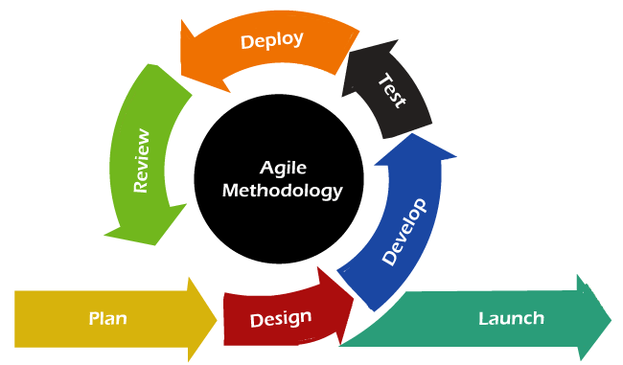
Figure: 3.2 Agile Model
The development of A Mobile Application for Dormitory and Boarding House Finder for Students in High-Demand Areas follows the Agile Software Development Model. The Agile methodology is an iterative and flexible approach that emphasizes collaboration, adaptability, and continuous improvement throughout the development process. This model is particularly suitable for mobile application development, as it allows for quick adjustments based on user feedback and evolving requirements.
Planning
During the planning phase, the researchers identified the common difficulties experienced by students in securing dormitory and boarding house accommodations, particularly within the high-demand areas of Batangas and Lipa. To gather relevant insights, they conducted informal interviews with students and reviewed existing online rental platforms to pinpoint recurring issues such as outdated listings, lack of contact information, and unverified posts. Using this information, the team defined the project scope, prioritized essential features such as real-time availability, offline access, and online payments, and outlined potential risks like internet dependency, data reliability, and device limitations.
Design
In the design stage, the researchers utilized Figma to create low-fidelity wireframes representing the main components of the mobile application, including the home interface, search and filter system, property detail views, and reservation process. They structured the user interface based on typical student behavior and preferences—opting for a clean, intuitive layout optimized for Android devices. The team also developed a clickable prototype to visualize the user flow and identify any navigational inconsistencies prior to the start of development.
Development
The researchers adopted a sprint-based development approach, dividing the overall workload into smaller, feature-focused tasks. In the initial sprint, they concentrated on core functions such as user registration and property listing management, implemented using Kotlin in Android Studio. The application’s backend relied on Firebase Firestore for storing user and property data and Firebase Authentication for managing secure logins. In subsequent sprints, they implemented offline dormitory viewing using local caching (via SharedPreferences), integrated real-time vacancy updates, and added a direct messaging feature to facilitate communication between students and landlords
.
Testing
After completing each sprint, the researchers conducted iterative testing using both Android Emulator and actual Android devices to ensure that the app functioned correctly across various screen sizes and performance levels. They performed manual exploratory testing to simulate realistic user behavior, including scenarios involving low or no internet connectivity.
Deployment
Upon achieving a stable application build, the researchers compiled and signed an APK file and distributed it to selected testers through platforms such as Google Drive. This allowed easy installation on Android devices without the need for formal marketplace deployment. The researchers also scheduled future deployments after major updates to ensure that users always had access to the most recent version of the application during evaluation.
Review and Feedback
To improve the application based on real user perspectives, the researchers gathered feedback from peers, potential student users, and several local landlords who reviewed the prototype. Feedback focused on enhancing the clarity of the search filters and simplifying the reservation process. The researchers documented and analyzed this input, incorporating feasible improvements into future development sprints. This continuous review cycle ensured that the system evolved in line with user needs, ultimately enhancing usability, accessibility, and overall user satisfaction.
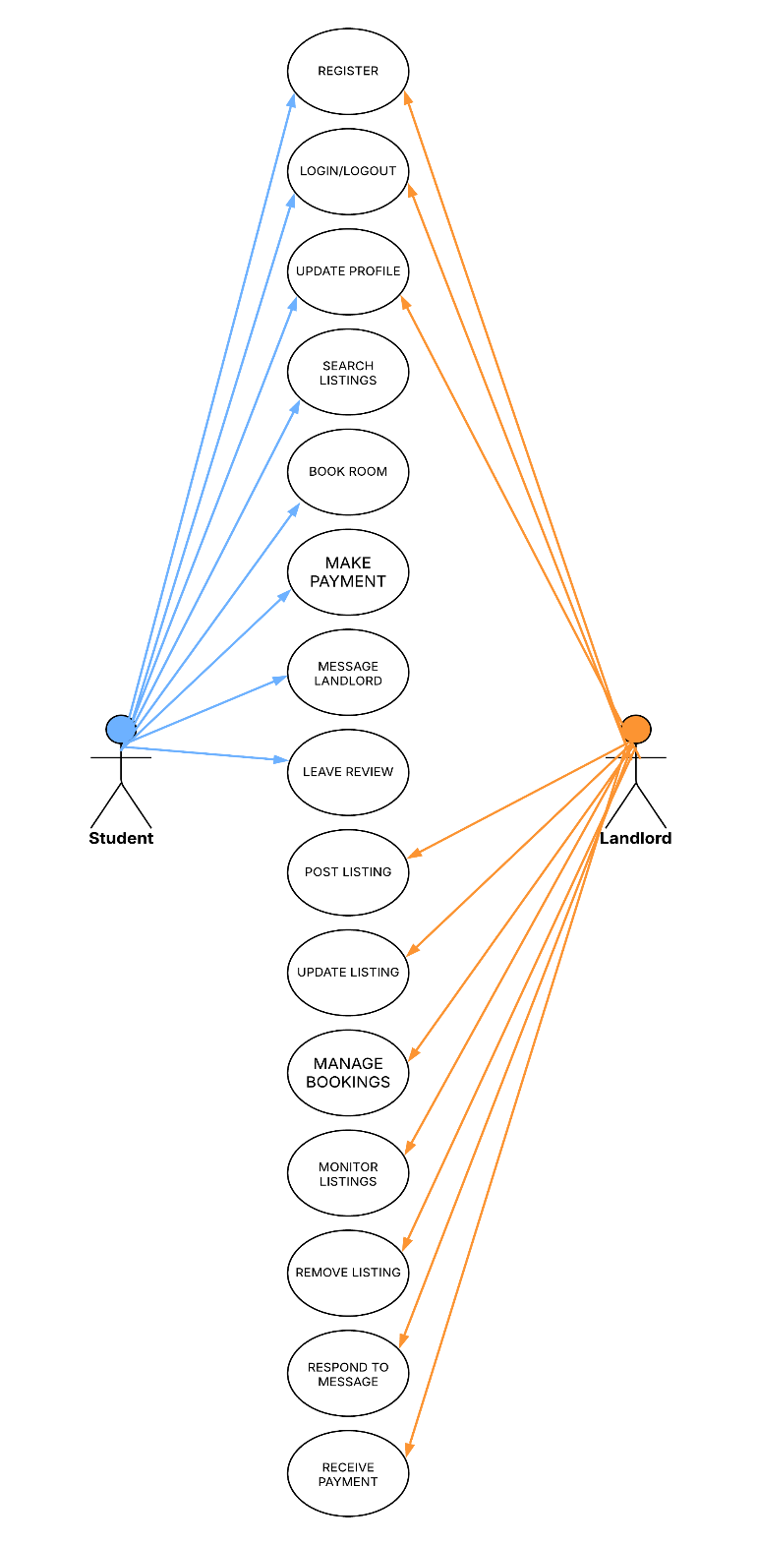
Figure: 3.3 Use Case Diagram
The system is designed to support two main user roles: Student and Landlord, each with specific functionalities tailored to their needs. Students can register, log in, search for listings, book rooms, send messages to landlords, leave reviews, update their profiles, make secure online payments, and log out. Landlords can register, log in, post and update property listings, manage bookings, monitor and remove listings, respond to student messages, receive online payments, and log out. Figure 3.3 presents the Use Case Diagram, which illustrates how these two user roles interact with the system and highlights the core functionalities that support an efficient and user-friendly accommodation platform.
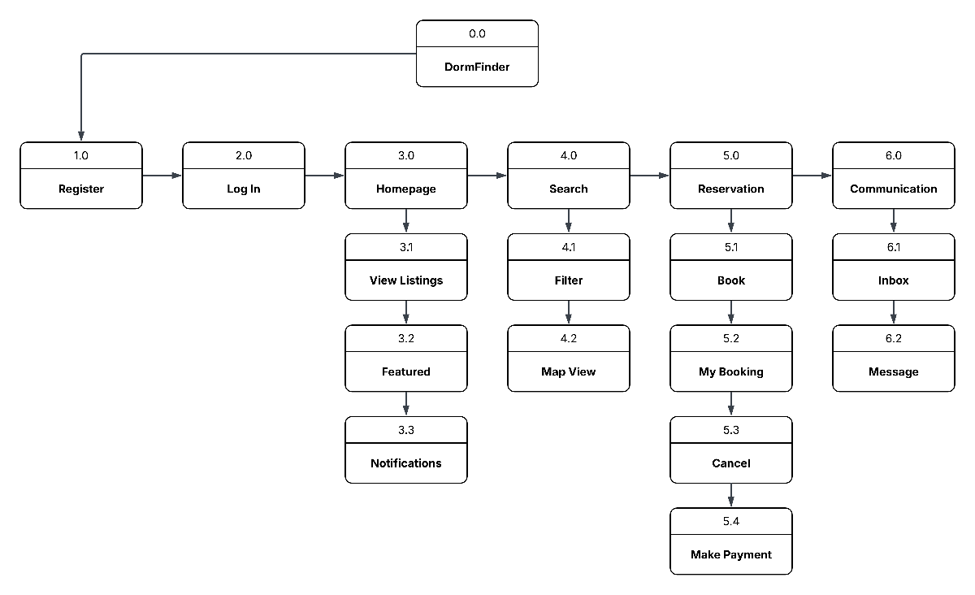
Figure: 3.4 Student HIPO Diagram
Figure 3.4 shows the DormFinder HIPO (Hierarchical Input Process Output) Diagram, which outlines the system's main functional sections and their hierarchical relationships. The diagram presents the core components of the application including Register, Log in, Homepage, Search, Reservations, and Communication modules.

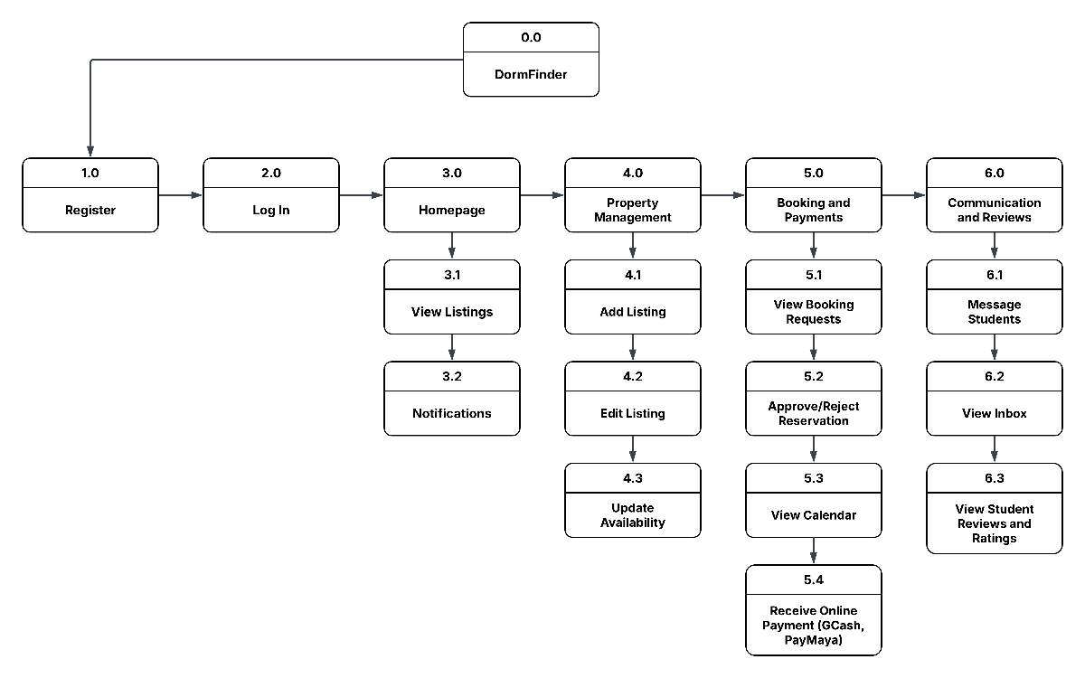
Figure: 3.5 Landlord HIPO Diagram
Figure 3.5 presents the Landlord HIPO Diagram, outlining the key functional modules for property owners including Property Management (4.0) with Add Listing (4.1), Edit Listing (4.2), and Update Availability (4.3) sub-functions; Booking and Payment (5.0) covering View Request (5.1), Approve/Reject (5.2), Calendar View (5.3), Receive Payment(5.4); and Communication (6.0) with Message Student (6.1) and Inbox (6.2) features, demonstrating the landlord-facing workflow from property listing to tenant communication.

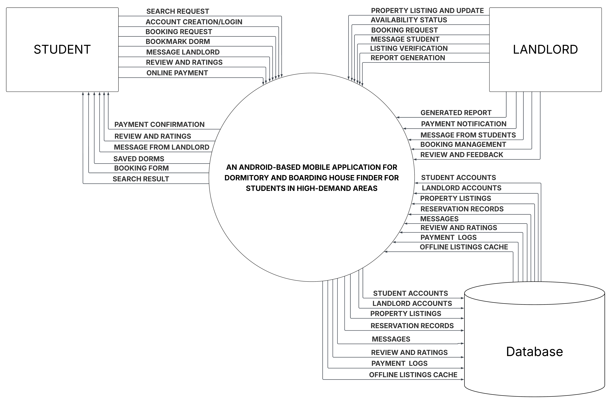
Figure: 3.6 Context Diagram
The Android-Based Dormitory and Boarding House Finder is a mobile application designed to connect students and landlords within Batangas and Lipa. Students can search listings (even offline), reserve rooms, message landlords, submit reviews, and make secure online payments. Landlords manage property listings, update availability in real-time, respond to bookings, communicate with students, and receive payments through the app. The system database stores all user accounts, property listings, reservations, messages, reviews, payment records, and cached offline data.

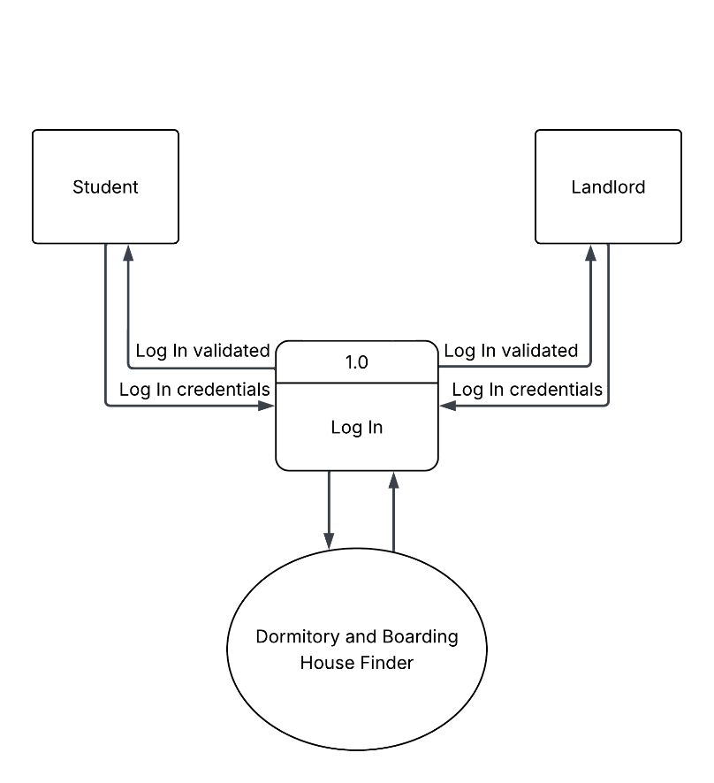
Figure: 3.7 Data Flow Diagram Level 1
This Level 1 Data Flow Diagram (DFD) details the "Registration" process (1.0), where Students, and Landlords submit their information to register into the system, and the Dormitory and Boarding House Finder stores their registration data and sends confirmation or feedback to each user.

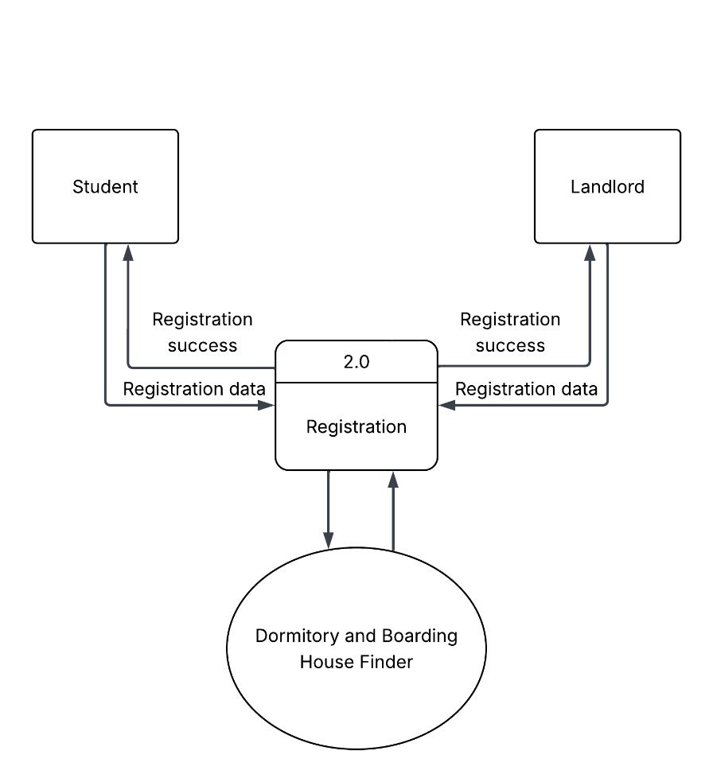
Figure: 3.8 Data Flow Diagram Level 2
This Level 2 Data Flow Diagram (DFD) illustrates the login process where three user types; Student, and Landlord interact with the "Log In" process (2.0), which authenticates them and grants access to the Dormitory and Boarding House Finder system.
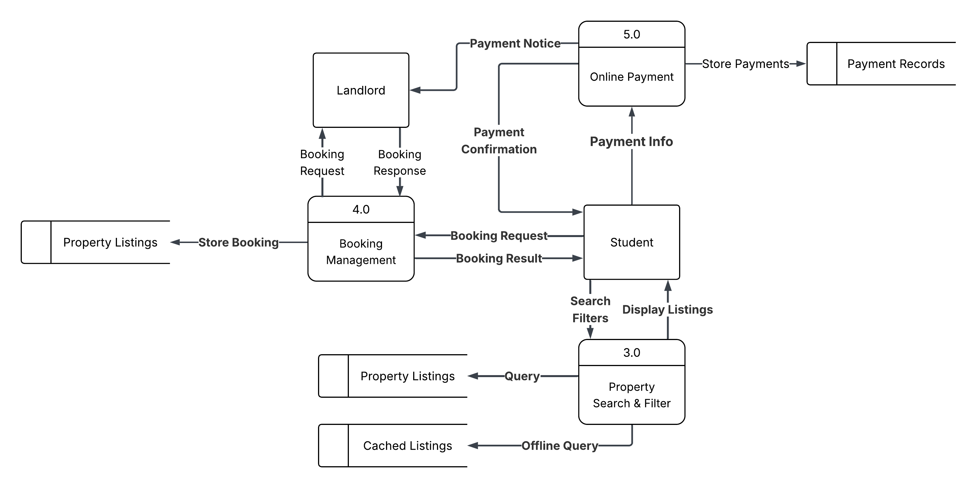
Figure: 3.9 Data Flow Diagram Level 3
This Level 3 Data Flow Diagram illustrates how students interact with the system to search and filter dormitory listings, manage reservations, and make online payments. Students can perform both online and offline searches using stored cached listings. They submit reservation requests, which are managed by the system and forwarded to landlords for approval. Landlords provide and update property listings, manage bookings, and receive payment confirmations directly through the application.
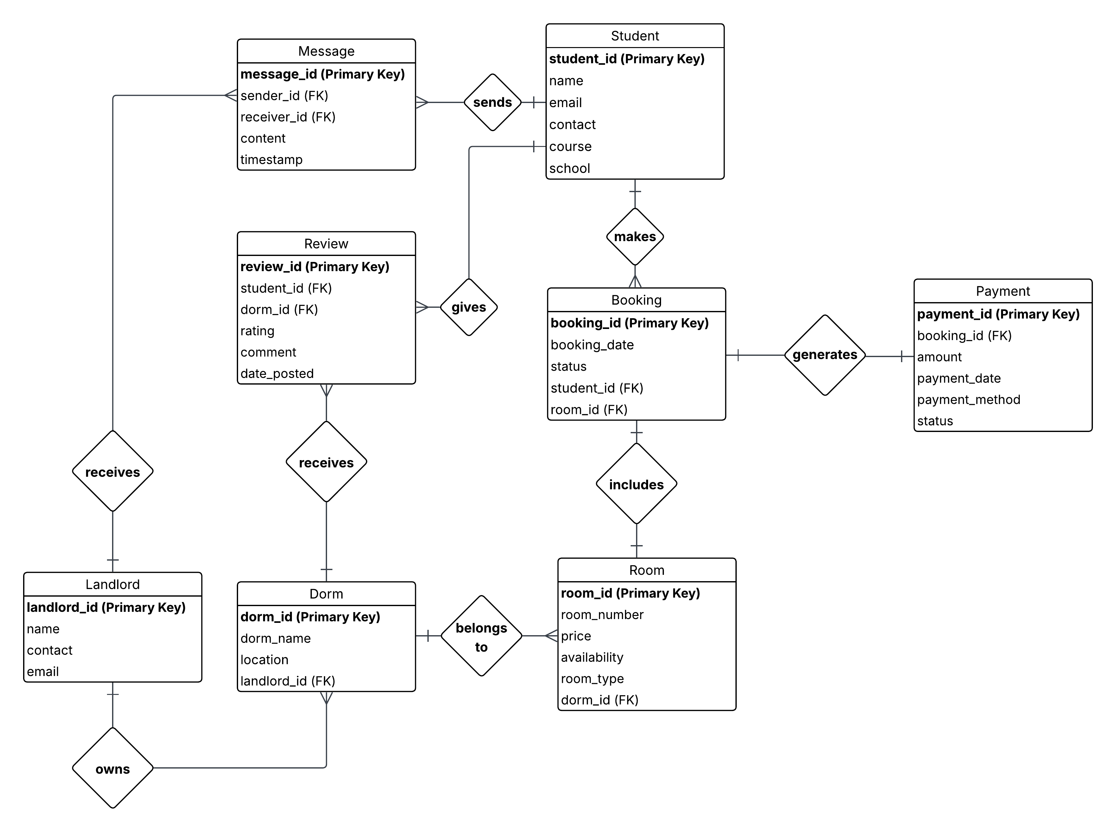
Figure: 3.10 Student Entity Relationship Diagram
The Student ERD illustrates how students interact with the dormitory booking system by creating bookings linked to specific rooms and dorms owned by landlords. Each booking can include a payment record, while students can also submit reviews for dorms and exchange messages with landlords through the system. This structure supports real-time booking, communication, and feedback, centralizing all student interactions in the mobile application.
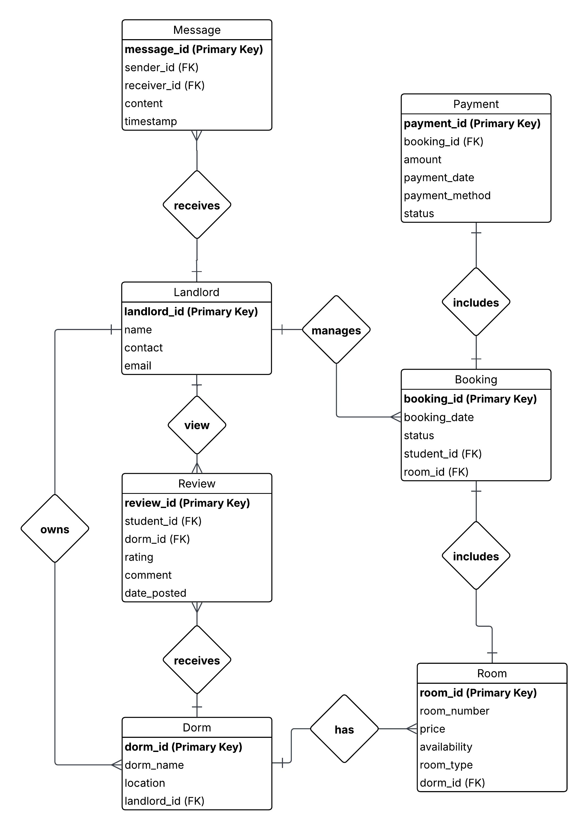
Figure: 3.11 Landlord Entity Relationship Diagram
The Landlord ERD illustrates how landlords manage their dormitory business through the mobile application. A landlord owns multiple dorms, each of which contains rooms that can be booked by students; these bookings result in payments that the landlord receives. Additionally, landlords can communicate with students through a messaging system and monitor feedback via student-submitted reviews linked to their dorms.

